

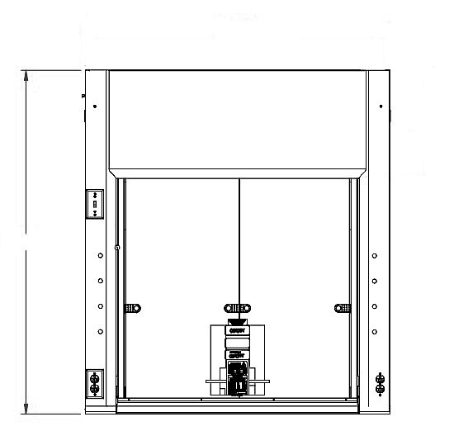

53.0”

**STANDARD FEATURES**

**Interior Baffle Arrangement**:

*Fixed Baffles (standard)*

**Exhaust Collar:** *(Select one.)*

Painted CRO Steel Standard.

**Interior Lighting Fixture**: *(Select one.)*

Standard LED Fixtures.

**Sash Frame & Glass**: *(Select one.)*

Laminated Safety Glass Standard.

**Air Foil**: *(Select one.)*

Painted CRO Steel Standard.

**Sash Type**: *Vertical (Standard)*

**Liner Material**: *(Select one.)*

Polyresin Standard.

**Pre-wire + Electrical** (*Standard Electrical Factory Prewired*):

Monitor / Alarm

Choose an item.

Light Switch (Standard)

Blower Switch (Optional)

**Specify Fittings / Fixtures Required**

**Specify Fittings / Fixtures Required**

 

 

 

 

120V GFI Duplex (Optional)

120V GFI Duplex (Optional)

Electrical Duplex (Optional)

Electrical Duplex (Optional)

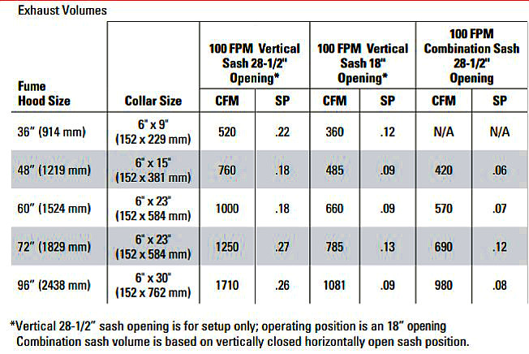**Customer**:

**OPTIONAL ACCESSORIES**

**Ceiling Enclosure?**



Hinged Access Panel on Ceiling Enclosures?

Finished Back?

**Sash Type**: Choose an item.

**Additional Options**: Sash Locks?

Sash Stops?

Electronic Sash Closer at Vertical Sash Only?

Sash Alarm?  Sash Cap?

**Service Fixture Type**: Choose an item.

(Height)

Click or tap here to enter text.

**Room #:** Click or tap here to enter text.

**Elevation #:** Click or tap here to enter text.

**Fume Hood #:** Click or tap here to enter text.

**Qty**.: Click or tap here to enter text.

**Pre-piping**: Click or tap here to enter text.

**Bypass Type**: Choose an item.

**Optional FH Depth:** Choose an item.

**Product Number:** Click or tap here to enter text.

**Special Requirements / Notes**: 36”  48”  60”  72”  96”

**Custom Sizes Available. Contact Hamilton.**

Click or tap here to enter text.

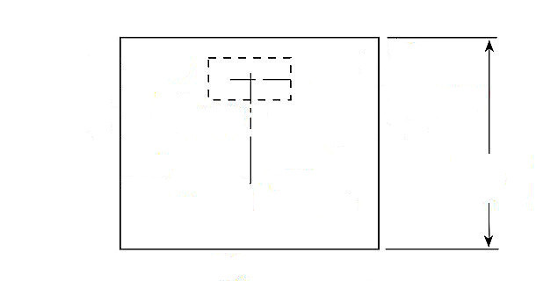

**29”, 35” or 41”**

**FUME VENT**

**(SIZE VARIES. SEE CHART)**

℄

**TABLE OF FUME VENT DIMENSIONS FOR VARIOUS FUME HOOD WIDTHS.**

|  |  |
| --- | --- |
| **Fume Hood Width** | **Fume Vent Dimensions** |
| 36” | 6” X 9” |
| 48” | 6” X 15” |
| 60” | 6“ X 23” |
| 72” | 6” X 23” |
| 84” | 6” X 26” |
| 96” | 6” X 30” |

**SERVICE ROUGH-IN DETAIL**

**(SEE TABLE AT RIGHT FOR FUME HOOD VENT SIZE BASED ON WIDTH OF FUME HOOD.)**

**Epoxy Work Surface**

**(Specify location of cupsink)**

*When utilizing 22” deep cabinets, cupsink measurement changes to 5.25” in lieu of 9”.

Note: At 5.25”, it will have the cup sink sit slightly under the baffle.

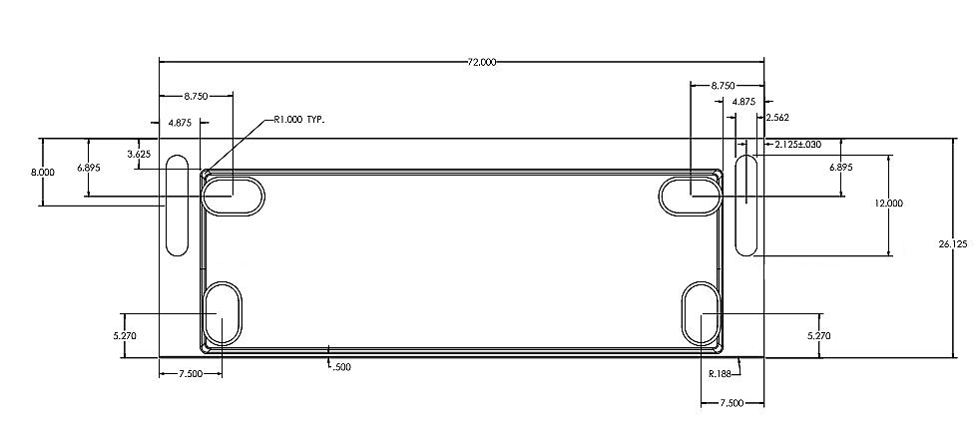

OPTIONAL CUPSINK CUTOUT LOCATIONS

**Include Acid Cabinet Vent Hole**?

**Cupsink Options**: Choose an item.

*Add 0.25” Raised Rim?*

**Work Surface Material**: Choose an item.